Create a Firewall

Contents

Installation of pfsense in Hyper-V 2

Basic Hyper-V Networking 2

creating virtual machine 4

Installing pfSense software 10

Connecting GUI 15

# Installation of pfsense in Hyper-V

## Basic Hyper-V Networking

1.Open the Hyper-V Manager

Click Virtual Switch manager from actions menu

Select Private for the type of virtual switch

Click Create Virtual Switch

Set the name for new switch to LAN

Create a switch for WAN networks

Click New Virtual Switch

Select External For the type of virtual Switch

Click Create Virtual Switch

Set the name for the newly added switch to WAN

Select the appropriate interface for the External network

After creating WAN and LAN Switchesm

## creating virtual machine

Click New> Virtual Machine from the Actions list

Name the VM and Specify the location

Specify the generation

Assign Memory

Click next and proceeding to the configure networking step

Select WAN from the connection drop down menu

Click Next to and Proceed to the Connect Virtual Hard Disk

Select Create a virtual hard disk

Assign 20 GB for the VM disk

Select install an operating system from a bootable image file

Browse to the pfsense software installer ISO file

Completing the new virtual machine wizard

Select finish

There are several settings have to be done on the VM before boot pfsense software

Right click pfsense VM select settings

Select Add hardware under the hardware in the left side pane

Select network adaptor, then add

Set the Virtual Switch to the LAN Switch created before

Click apply, then select security under Hardware in the left side panel

Uncheck Enable secure boot

Click apply, then select firmware

Select hard drive in the boot order list and click move up till top of the list

## Installing pfSense software

Open Hyper-V manager

Right click the pfSense VM and select connect or click connect in the actions panel in the right

Click start

Accept the copyright

Select ok to install pfSense

Continue with default keyboard map

Select auto UFS Bios

Select NO when prompted to make final modifications

Select Reboot to restart the firewall

Enter n and press enter to key to skip vlan setup

Enter hn0 for WAN interface

Enter hn1 for LAN interface

Enter y to proceed

After assigning interfaces, pfSense software will finish the boot-up. Verify both interfaces have the correct IP addresses

## Connecting GUI

On the client computer, open a web browser such as Firefox, Safari, or Chrome and navigate to [https://192.168.1.1](https://192.168.1.1/)

Enter the default credentials in the login page:

**username**

admin

**password**

pfsense

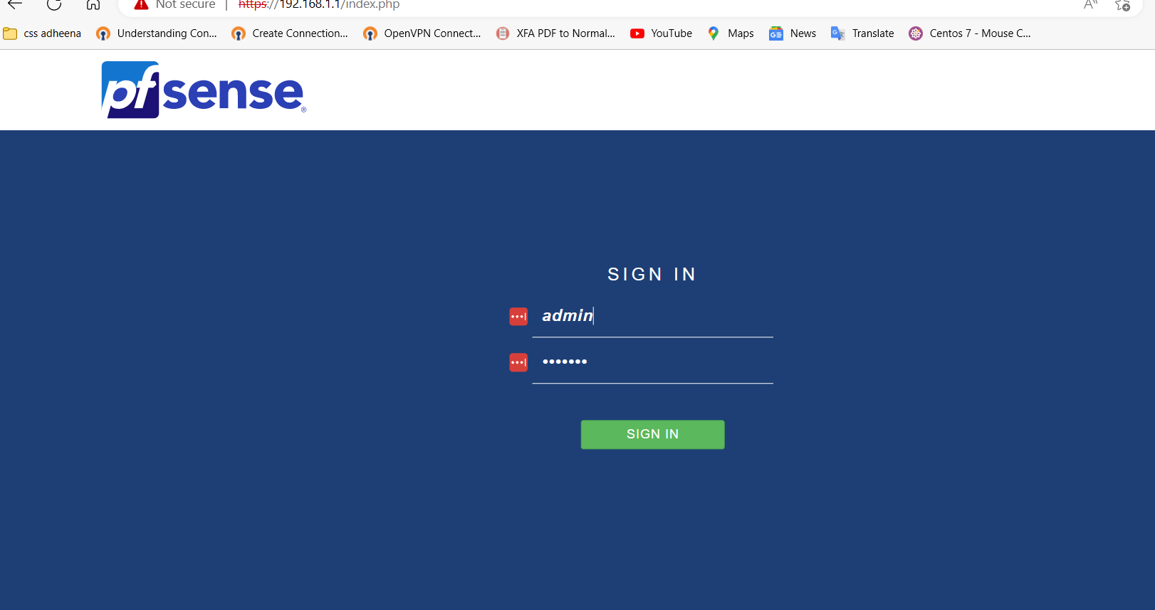

Untick enable DNS resolver

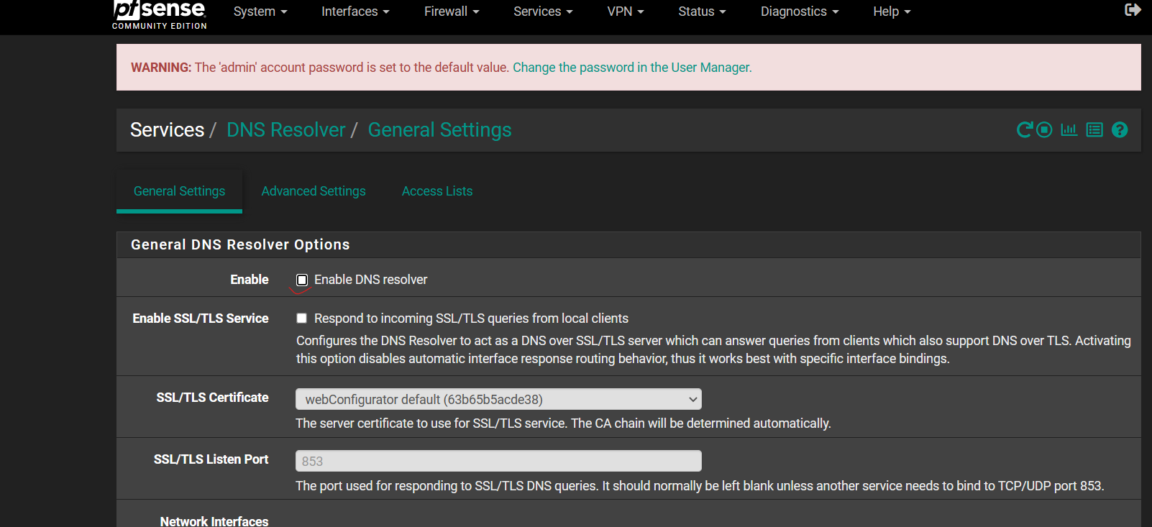

Untick enable dhcp server on LAN interface

Add a user _LSysadmin

Check NAT

